**Workflow document**

Nabu

Curation Using Almaren

Oct 1, 2020

Version 0.1



Contents

1. Almaren code using Zeppelin 2

2. Curation Using Almaren 5

**2.1. Prerequisites:** 5

**2.2. Steps to be followed:** 5

# Almaren code using Zeppelin

Users can develop and test the Almaren code in Apache Zeppelin notebook.

**Apache Zeppelin URL:**

<https://arch-data-engineering-master3.arch-env.u55l-xcud.cloudera.site/arch-data-engineering/cdp-proxy/zeppelin/#/>

Below is an example of PCSDW triple creation that we can run it in zeppelin notebook.

-----------------------------------------------------------------------------------------------------------------------

import com.github.music.of.the.ainur.almaren.builder.Core.Implicit

import com.github.music.of.the.ainur.almaren.Almaren

import org.apache.spark.sql.DataFrame

val almaren = Almaren("pcsdw")

val res = almaren.builder.sourceSql("""

with RESULT_LX_RPT_VW AS (

SELECT STUDY_ID,STUDY_NUMBER, STUDY_GROUP_ID, SRC_GROUP_NUMBER,PHASE_ID, DAY_OF_PHASE, MEAS_AREA, SPECIES_NAME, MEAS_NAME, NUMERIC_VALUE AS RESULT, 'Cmpd (Root)' as ENTITY1_TYPE,

MEAS_NAME as ENTITY2,

MEAS_AREA as ENTITY2_TYPE,

MEAS_UNIT_NAME as RESULT_TYPE

FROM preclinical.t_ddmlcnp1_pcsdw_result_lx_rpt_vw

WHERE MEAS_AREA IN ('Chemistry Measurement','Hematology Measurement','Urine Chemistry Measurement','Urinalysis Measurement')

AND SPECIES_NAME IN ('Rat')

AND MEAS_NAME IN ('Leukocytes','Neutrophil','Basophil','Eosinophil','Monocytes','Platelet','High RNA Reticulocytes')

AND NUMERIC_VALUE IS NOT NULL ),

STUDYGROUP_DOP_SUMMARY_VW AS (

SELECT STUDY_GROUP_ID, PHASE_ID, DAY_OF_PHASE, AVG_VALUE AS VEHICLE_GROUP_MEAN,1 AS STRENGTH

FROM preclinical.t_ddmlcnp1_pcsdw_studygroup_dop_summary_vw ),

STUDY_GROUP_COMPOUND_VW AS (

SELECT STUDY_NUMBER, STUDY_ID,STUDY_GROUP_ID ,SRC_GROUP_NUMBER,TEST_ARTICLE as ENTITY1

FROM preclinical.t_ddmlcnp1_pcsdw_study_group_compound_vw

),

JOINED_DATA AS (

select *,CASE WHEN NORMALIZED_RESULT >0 THEN "Increasing"

WHEN NORMALIZED_RESULT <0 THEN "Decreasing"

WHEN NORMALIZED_RESULT = 0 THEN "No Effect" else NORMALIZED_RESULT end as REL_TYPE

from (

SELECT A.*, B.VEHICLE_GROUP_MEAN, ENTITY1, (A.RESULT - B.VEHICLE_GROUP_MEAN) / B.VEHICLE_GROUP_MEAN AS NORMALIZED_RESULT,B.STRENGTH

FROM RESULT_LX_RPT_VW A INNER JOIN STUDYGROUP_DOP_SUMMARY_VW B ON

A.STUDY_GROUP_ID = B.STUDY_GROUP_ID

AND A.PHASE_ID = B.PHASE_ID

AND A.DAY_OF_PHASE = B.DAY_OF_PHASE INNER JOIN STUDY_GROUP_COMPOUND_VW C

ON A.STUDY_ID = C.STUDY_ID and A.STUDY_GROUP_ID = C.STUDY_GROUP_ID and A.STUDY_NUMBER = C.STUDY_NUMBER AND A.SRC_GROUP_NUMBER= C.SRC_GROUP_NUMBER

)X )

SELECT RESULT, ENTITY1, ENTITY1_TYPE, ENTITY2, ENTITY2_TYPE, RESULT_TYPE, REL_TYPE,STRENGTH, METADATA

FROM (

SELECT struct(MEAS_AREA,SPECIES_NAME,MEAS_NAME,STUDY_GROUP_ID,PHASE_ID,DAY_OF_PHASE,VEHICLE_GROUP_MEAN,NORMALIZED_RESULT) as METADATA,

RESULT, ENTITY1, ENTITY1_TYPE, ENTITY2, ENTITY2_TYPE, RESULT_TYPE, REL_TYPE,STRENGTH

FROM JOINED_DATA

)X

""").batch

res.write.mode("OVERWRITE").option("format", "parquet").option("path","s3a://arch-data-lake-dev/data/warehouse/integrated/preclinical.db/pcsdw_triples_v2").saveAsTable("preclinical.pcsdw_triples_v2")

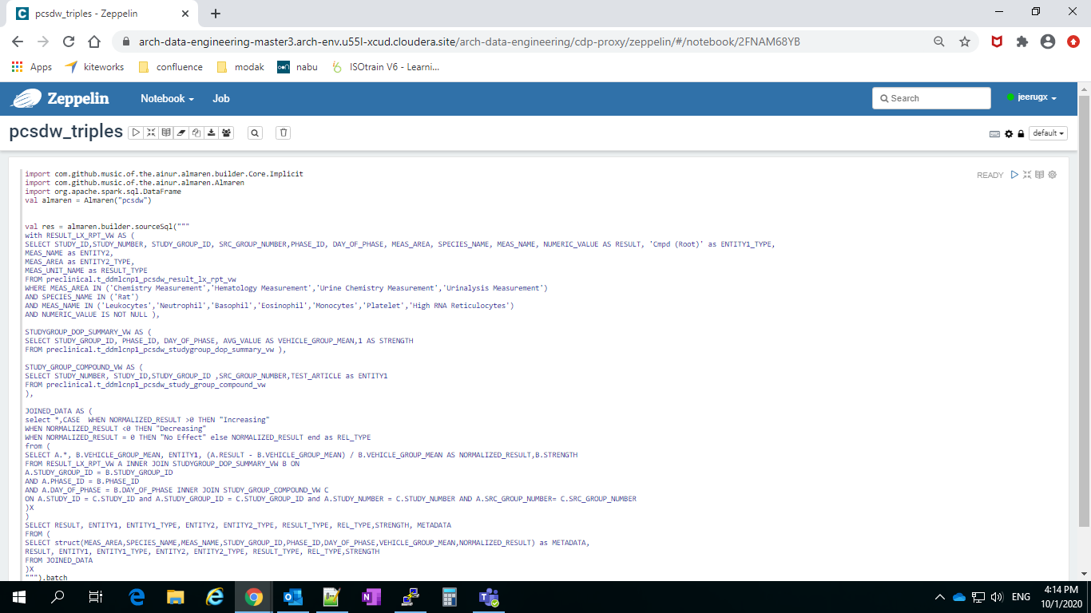

# Curation Using Almaren

## **2.1. Prerequisites:**

1. Almaren code should be uploaded in AbbVie GitHub.
2. Access to **kosh** database where nabu data model is residing.
   1. Postgres server details

|  |  |
| --- | --- |
| Host name | arch-nabu-dev-instance-1.caurfctzkbwj.us-east-1.rds.amazonaws.com |
| Port | 5432 |
| Database name | kosh |

* 1. We can use any account which has all privileges like SELECT, INSERT, UPDATE. For example, **SVC-ARCH-PG3-RW**

1. Access to ARCH-CDP environment (ARCH-DATA-ENGINEERING cluster)

## **2.2. Steps to be followed:**

1. Create a data movement by following below steps:
   1. Run below query on Nabu PostgreSQL instance by changing necessary parameters:

*INSERT INTO nabu.data_movement_physical*

*(data_movement_name, contact_info, data_movement_type, refresh_freq, dataplace_sub_component_id, data_movement_engine_id, workflow_engine_id, workflow_id, valid_to_ts, valid_from_ts, crt_by, crt_ts, mod_by, mod_ts, data_movement_additional_info)*

*VALUES('<data_movement_name>', '{}', 'curation', '<Provide cron expression of schedule time>', 0, 0, 1, 34, '9999-12-31', now(), 'Modak', now(), 'Modak', now(),*

*'{*

*"curation_details": {*

*"directory_path": "<git project directory name>",*

*"file_path": "<path of the almaren code we need to execute as present in git>",*

*"git_url": "<git clone url using ssh>"*

*}*

*-- “note”:”advanced options is optional”*

*--, “advanced_options”: {*

*-- "driver_memory": "<driver memory needed to run the specific job>",*

*--"executor_memory: "<executor memory needed to run the specific job>",*

*--"num_executors": "<num executors needed",*

*--"no_of_cores": "<number of cores>",*

*--"git_branch": "<git tag name or branch name>",*

*--"packages": "<external packages needed for the respective Almaren code>"*

*--}*

*}');*

Note: Please change the above parameters as shown below.

|  |  |  |
| --- | --- | --- |
| **Placeholder** | **Example** | **Reference** |
| <git project directory name> | *preclinical_curation* |  |
| <path of the almaren code we need to execute as present in git> | *preclinical_curation/pcsdw/pcsdw_triples_to_hive.txt* |  |
| <git clone url using ssh> | *git@pig.abbvienet.com:arch/preclinical_curation.git* |  |

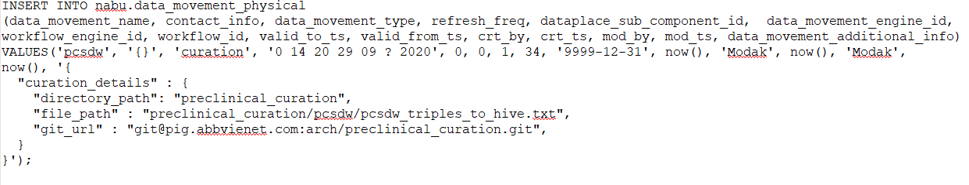Example query:

1. You can confirm your data_movement details after insertion by running below query

*select \**

*from nabu.data_movement_physical*

*where 1=1*

*and data_movement_name=’<datamovement_name as mentioned above>’*

*and data_movement_type='curation'*

*and valid_to_ts=’9999-12-31’*

Example:

*select \**

*from nabu.data_movement_physical*

*where 1=1*

*and data_movement_name=’* *preclinical_curation’*

*and data_movement_type='curation'*

*and valid_to_ts=’9999-12-31’*

This query shows all the details regarding your curation pipeline. Save the data movement id for further modifications of data movement.

1. To reschedule the job, you can update the refresh frequency by running below query

*update nabu.data_movement_physical*

*set refresh_freq=’<Provide new cron expression>’*

*where data_movement_id=<data_movement_id>*

*and data_movement_type='curation'*

*and valid_to_ts=’9999-12-31’*

*Example:*

*update nabu.data_movement_physical*

*set refresh_freq='0 45 19 29 09 ? 2020'*

*where data_movement_id=215*

*and data_movement_type='curation'*

*and valid_to_ts=’9999-12-31’*

1. *To check the status of the job run below query with your data_movement_id.*

*with get_batch_id as (*

*select batch_id*

*from(*

*select row_number()over(order by flow_ts desc) as rownum,batch_id*

*from nabu.flow_status*

*where flow_name ~*'curation_<data_movement_id>'*

*and status_code_id = 10*

*)a*

*where rownum = 1*

*)*

*select batch_id, status*

*from (*

*select \**

*,case when status_code_id = 7 then 'error'*

*when process_context = 'jdbc_insert_script_details' and status_code_id = 6 then 'success'*

*else 'running'*

*end as status*

*,row_number() over(partition by batch_id order by task_ts desc) as rownum*

*from nabu.job_load_result*

*where batch_id in (select batch_id from get_batch_id)*

*)x*

*where rownum = 1*

1. Once the data movement is completed. We can verify the data by checking in Hive for the table which you have created in your Almaren code.